11 Editors - Drivers
Timeline Editor 2
Timeline Elements 3
Time Cursor 3
Keyframes 3
Markers 3
Adjusting the View 4
Timeline Area 4
Timeline Header 4
View Menu 4
Marker Menu 5
Frame Menu 5
Playback Menu 5
Header Controls 6
1. Range Control 6
2. Frame Control 6
3. Player Control 6
4. Synchronize Playback 7
5. Keyframe Control 7
User Preferences 9
Graph Editor 9
Curve Editor Area 10
2D Cursor 10
View Axes 10
Markers 10
Header 11
Header Controls 11
Channels Region 12
Channel Editing 13
Properties Region 13
View Properties Panel 13
Active F-Curve Panel 14
Active Keyframe Panel 14
Drivers Panel 15
Modifiers Panel 15
F-Curves 15
Settings 16
Interpolation Mode 16
Extrapolation 17
Handle Types 18
Direction of time 19
Editing Tools 20
Transform Snapping 20
Mirror 21
Clean Keyframes 21
Smoothing 21
Sampling and Baking Keyframes 22
F-Curve Modifiers 22
Adding a Modifier 22
Types of Modifiers 22
Generator 22
Built-in Function 23
Envelope 23
Cycles 24
Noise 24
Python 24
Limits 24
Stepped 24
Dope Sheet 25
Action Editor 25
Action Data-Blocks 26
Channel Menu 26
The Dopesheet 26
Dope Sheet Modes 27
Interface 28
View Menu 29
Marker Menu 29
Shape Key 30
Non-Linear Animation Editor 30
Tracks 30
Strips 30
Creating Action Strips 30
Creating Transition Strips 30
Grouping Strips into Meta Strips 31
Editing Strips 31
Re-Instancing Strips 32
Strip Properties 33
Renaming Strips 33
Active Track 33
Active Strip 33
Active Action 34
Evaluation 34
Strip Modifiers 35

Timeline Editor

The Timeline window, identified by a clock icon, is shown by default at the bottom of the screen.
Timeline
The Timeline is not much of an editor, but more of a information and control window.
Here you can have an overview of the animation part of your scene
What is the current time frame, either in frames or in seconds, where are the keyframes of the active object, the start and end frames of your animation, markers, etc...
The Timeline has Player Controls, to play, pause the animation, and to skip though parts of the scene.
It also has some tools for Keyframes, Keying Sets, and Markers.

Timeline Elements

Time Cursor
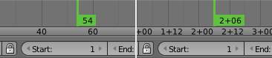
Time Cursor
The Time Cursor is the green line, its used to set and display the current time frame.
The Time Cursor can be set or moved to a new position by pressing or holding LMB in the Timeline window.
The current frame or second can be displayed on the Time Cursor, check the View menu for settings.
The Time Cursor can be moved in steps by pressing Left or Right, or in steps of 10 frames by pressing Shift-Up or Shift-Down.

Keyframes
For the active and selected objects, keyframes are displayed as a yellow line.
For Armatures, the object keyframes and the pose bones keyframes are drawn.
Only Selected Channels can be enabled. Timeline > View > Only Selected Channels. For Armatures, this will draw the object keyframes, and the keyframes for the active and selected pose bones.

Markers
Markers are the small triangles, with their name near them.
Markers are usually used to identify key parts of the animation.
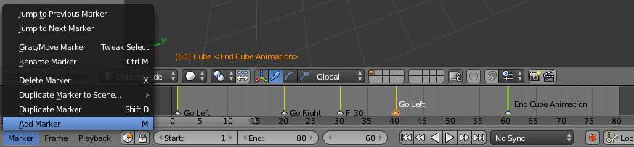
Markers
Markers can be selected by pressing RMB or Shift-RMB to select more.
See Marker Menu below or Markers for more info.

Adjusting the View

Timeline Area
The main Timeline area displays the animation frames over time.
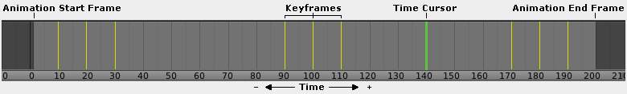
Timeline Main Area
The Timeline can be panned by holding MMB, then dragging the area left or right.
You can zoom the Timeline by using Ctrl-MMB, the mouse Wheel, or pressing the Minus and Plus keys on the numpad.
By default, the Playback/Rendering Range (Frame Start 1 to Frame End 200) is a lighter shade of gray. The start and end frame can be set to the Time Cursor by pressing S or E. The Playback Range can also be set by pressing P then drawing a box.

Timeline Header

View Menu
The View Menu controls what you see, and what it looks like.
Toggle Full Screen
Maximize or minimize the Timeline window. Ctrl-Up or Ctrl-Down
Duplicate Area into New Window
This creates a new OS window, and sets the editor window to the Timeline.
Bind Camera to Markers
This is used switch cameras during animation. It binds the active camera to the selected markers. First select a camera. Then select the marker(s). Then use the function. Ctrl-B
Cache
This will display the baked Cache Steps for the active object.
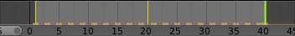
Timline Cache
Show Cache
Show all enabled types.
Softbody, Particles, Cloth, Smoke, Dynamic Paint, Rigid Body.
Only Selected Channels
For Armatures, this will draw the object keyframes, and the keyframes for the active and selected pose bones.
Show Frame Number Indicator
This will draw the current frame or seconds on the Time Cursor.
View All
Maximize the Timeline area based on the Animation Range. Home
Show Seconds
Show time in seconds for the Timeline and the Time Cursor based on the FPS.

Marker Menu
Jump to Previous Marker
Jump to Next Marker
Grab/Move Marker
Grab/Move the selected markers. G
Rename Marker
Rename the active marker.
Delete Marker
Delete selected markers.
Duplicate Marker to Scene...
Duplicate the selected markers to another scene.
Duplicate Marker
Duplicate the selected markers.
Add Marker
Add marker to the current frame.

Frame Menu
Auto-Keyframing Mode
This controls how the Auto Keyframe mode works. Only one mode can be used at a time.
Add & Replace
Add or Replace existing keyframes.
Replace
Only Replace existing keyframes.

Playback Menu
- Audio Scrubbing If your animation has sound, this option plays bits of the sound wave while you move the time cursor with LMB or keyboard arrows.
- Audio Muted Mute the sound from Sequence Editors.
- AV-sync Play back and sync with audio clock, dropping frames if frame display is too slow. See 4. Synchronize Playback for more info.
- Frame Dropping Play back dropping frames if frames are too slow. See 4. Synchronize Playback for more info.
- Clip Editors While playing, updates the Movie Clip Editor.
- Node Editors While playing, updates the Node properties for the Node Editor.
- Sequencer Editors While playing, updates the Video Sequence Editor.
Note
Image Editors
TODO Not sure what is updated, maybe gif images or, image sequence.

- Image Editors Todo
- Property Editors When the animation is playing, this will update the property values in the UI.
- Animation Editors While playing, updates the Timeline, Dope Sheet, Graph Editor, Video Sequence Editor.
- All 3D View Editors While playing, updates the 3D View and the Timeline.
- Top-Left 3D Editor While playing, updates the Timeline if Animation Editors and All 3D View Editors disabled.

Header Controls
The Timeline header controls.
Timeline header controls.

1. Range Control
Use Preview Range
This is an alternative range used to preview animations. This works for the UI playback, this will not work for rendering an animation.
Lock Time Cursor to Playback Range
This limits the Time Cursor to the Playback Range.

2. Frame Control
Start Frame
The start frame of the animation / playback range.
End Frame
The end frame of the animation / playback range.
Current Frame
The current frame of the animation / playback range. Also the position of the Time Cursor.

3. Player Control
These button are used to set, play, rewind, the Time Cursor.
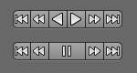
Player Controls.
Jump to start
This sets the cursor to the start of frame range.
Jump to previous keyframe
This sets the cursor to the previous keyframe.
Rewind
This plays the animation sequence in reverse. SWhen playing the play buttons switch to a pause button.
Play
This plays the animation sequence. When playing the play buttons switch to a pause button.
Jump to next keyframe
This sets the cursor to the next keyframe.
Jump to end
This sets the cursor to the end of frame range.
Pause
This stops the animation.

4. Synchronize Playback
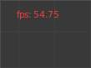
3D View Red FPS. 60:54.75
When you play an animation, the FPS is displayed at the top left of the 3D View. If the scene is detailed and playback is slower than the set Frame Rate (see Dimensions Presets, these options are used to synchronize the playback.
No Sync
Do not sync, play every frame.
Frame Dropping
Drop frames if playback is too slow. This enables Frame Dropping from the Playback Menu.
AV-sync
Sync to audio clock, dropping frames if playback is slow. This enables AV-sync and Frame Dropping from the Playback Menu.

5. Keyframe Control
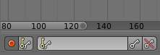
Timeline Auto Keyframe.
Auto Keyframe
The “Record” red-dot button enables something called Auto Keyframe : It will add and/or replace existing keyframes for the active object when you transform it in the 3D view.
For example, when enabled, first set the Time Cursor to the desired frame, then move an object in the 3d view, or set a new value for a property in the UI.
When you set a new value for the properties, Bforartists will add keyframes on the current frame for the transform properties.
Auto Keying Set - Optional if Auto Keyframe enabled. Auto Keyframe will insert new keyframes for the properties in the active Keying Set.
Note that Auto Keyframe only works for transform properties (objects and bones), in the 3D views (i.e. you cant use it e.g. to animate the colors of a material in the Properties window...).
Note
Layered
Todo.

Timeline Layered.
Layered - Optional while playback. TODO.
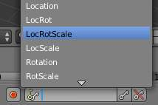
Timeline Keying Sets.
Active Keying Set
Keying Sets are a set of keyframe channels in one.
They are made so the user can record multiple properties at the same time.
With a keying set selected, when you insert a keyframe, Bforartists will add keyframes for the properties in the active Keying Set.
There are some built in keying sets, ‘LocRotScale’, and also custom keying sets.
Custom keying sets can be defined in the in the panels Properties > Scene > Keying Sets + Active Keying Set.
Insert Keyframes
Insert keyframes on the current frame for the properties in the active Keying Set.
Delete Keyframes
Delete keyframes on the current frame for the properties in the active Keying Set.

User Preferences
Some related user preferences from the Editing tab.
Playback
Allow Negative Frames
Time Cursor can be set to negative frames with mouse or keyboard. When using Use Preview Range, this also allows playback.
Keyframing
Visual Keying
When an object is using constraints, the objects property value doesnt actually change. Visual Keying will add keyframes to the object property, with a value based on the visual transformation from the constraint.
Only Insert Needed
This will only insert keyframes if the value of the propery is different.
Auto Keyframing
Enable Auto Keyframe by default for new scenes.
Show Auto Keying Warning
Displays a warning at the top right of the 3D View, when moving objects, if Auto Keyframe is on.
Only Insert Available
With Auto Keyframe enabled, this will only add keyframes to channel F-Curves that already exist.

Graph Editor

The graph editor is the main animation editor. It allows you to modify the animation for any properties using F-Curves.
The graph editor has two modes, F-Curve for Actions, and Drivers for Drivers. Both are very similar in function.
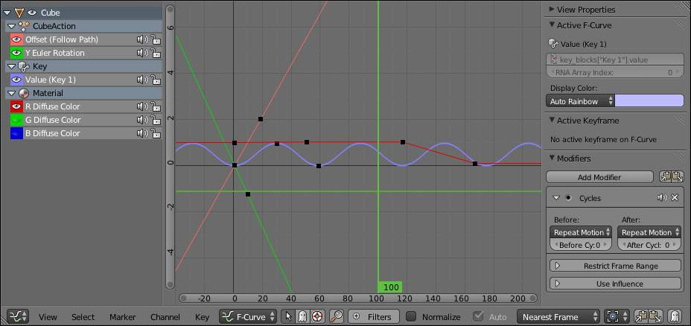
The Graph Editor.

Curve Editor Area
Here you can see and edit the curves and keyframes.
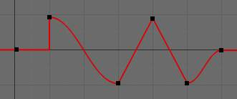
A curve with different types of interpolation.
See F-Curves for more info.

2D Cursor
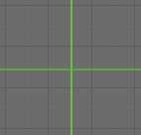
Graph Editor 2D Cursor.
The current frame is represented by a green vertical line called the Time Cursor.
As in the Timeline, you can change the current frame by pressing or holding LMB.
The green horizontal line is called the Cursor. This can be disabled via the View Menu or the View Properties panel.
The Time Cursor and the Cursor make the 2D Cursor. The 2D Cursor mostly used for editing tools.

View Axes
For Actions the X-axis represents time, the Y-axis represents the value to set the property.
For Drivers the X-axis represents the Driver Value, the Y-axis represents the value to set the property.
Depending on the selected curves, the values have different meaning: For example rotation properties are shown in degrees, location properties are shown in Bforartists Units. Note that Drivers use radians for rotation properties.

Markers
Like with most animation editors, markers are shown at the bottom of the editor.
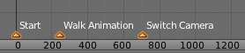
Graph Editor Markers.
Markers can be modified in the Graph Editor though its usually best to use the Timeline.
See Markers for more info.

Header
Here you’ll find.
- The menus.
- Graph Editor mode.
- View controls.
- Curve controls.

Header Controls
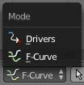
Graph Mode.
Mode
F-Curve for Actions, and Drivers for Drivers.
View Controls.
View controls
Show Only Selected
Only include curves related to the selected objects and data.
Show Hidden
Include curves from objects/bones that are not visible.
Show Only Errors
Only include curves that are disabled or have errors.
Search Filter
Only include curves with keywords contained in the search text.
Type Filter
Filter curves by property type.
Normalize
Normalize curves so the maximum or minimum point equals 1.0 or -1.0.
Auto
Automatically recalculate curve normalization on every curve edit.
Curve Controls.
Curve controls
Auto Snap
Auto snap the keyframes for transformations.
No Auto-Snap Time Step Nearest Frame Nearest Marker
Pivot Point
Pivot point for rotation.
Bounding Box Center
Center of the select keyframes.
2D Cursor
Center of the 2D Cursor. Time Cursor + Cursor.
Individual Centers
Rotate the selected keyframe Bezier handles.
Copy Keyframes
Copy the selected keyframes to memory.
Paste Keyframes
Paste keyframes from memory to the current frame for selected curves.
Create Snapshot
Creates a picture with the current shape of the curves.

Channels Region
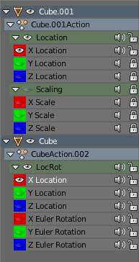
Channels Region.
The channels region is used to select and manage the curves for the graph editor.
Hide curve
Represented by the eye icon.
Deactivate/Mute curve
Represented by the speaker icon.
Lock curve from editing
Represented by the padlock icon.

Channel Editing
Select channel
Multi Select/Deselect
Toggle Select All
Border Select
Border Deselect
Delete selected
Lock selected
Make only selected visible
Enable Mute Lock selected
Disable Mute Lock selected
Toggle Mute Lock selected

Properties Region
The panels in the Properties Region.

View Properties Panel
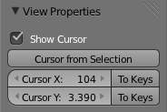
View Properties Panel.
Show Cursor
Show the vertical Cursor.
Cursor from Selection
Set the 2D cursor to the center of the selected keyframes.
Cursor X
Time Cursor X position.
To Keys
Snap selected keyframes to the Time Cursor.
Cursor Y
Vertical Cursor Y position.
To Keys
Snap selected keyframes to the Cursor.

Active F-Curve Panel
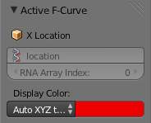
Active F-Curve Panel.
This panel displays properties for the active F-Curve.
Channel Name (X Location)
ID Type + Channel name.
RNA Path
RNA Path to property + Array index.
Color Mode
Color Mode for the active F-Curve.
Auto Rainbow
Increment the HUE of the F-Curve color based on the channel index.
Auto XYZ to RGB
For property sets like location xyz, automatically set the set of colors to red, green, blue.
User Defined
Define a custom color for the active F-Curve.

Active Keyframe Panel
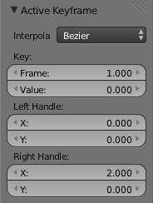
Active Keyframe Panel.
Interpolation
Set the forward interpolation for the active keyframe.
Constant
Keep the same value till the next keyframe.
Linear
The difference between the next keyframe.
Bezier
Bezier interpolation to the next keyframe.
Key
Frame
Set the frame for the active keyframe.
Value
Set the value for the active keyframe.
Left Handle
Set the position of the left interpolation handle for the active keyframe.
Right Handle
Set the position of the right interpolation handle for the active keyframe.

Drivers Panel
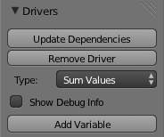
Drivers Panel.
See Drivers Panel for more info.

Modifiers Panel
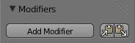
Modifiers Panel.
See F-Modifiers for more info.
See also
- Graph Editor - F-Curves
- Graph Editor - F-Modifiers
- Actions
- Drivers

F-Curves

After animating some property in Bforartists using keyframes you can edit their corresponding curves. When something is “animated,” it changes over time. This curve in shown as something called an F-Curve. Basically what an F-Curve does is it a interpolates between two animated properties. In Bforartists, animating an object means changing one of its properties, such as an objects location, or its scale.
As mentioned, Bforartists’s fundamental unit of time is the “frame”, which usually lasts just a fraction of a second, depending on the frame rate of the scene. As animation is composed of incremental changes spanning multiple frames, usually these properties ARE NOT manually modified frame by frame, because:
- it would take ages!
- it would be very difficult to get smooth variations of the property (unless you compute mathematical functions and type a precise value for each frame, which would be crazy).
This is why nearly all direct animation is done using interpolation.
The idea is simple: you define a few Key Frames, which are multiple frames apart. Between these keyframes, the properties’ values are computed (interpolated) by Bforartists and filled in. Thus, the animators’ workload is significantly reduced.
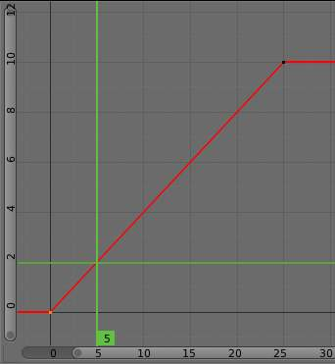
Example of interpolation
For example, if you have:
- a control point of value 0 at frame 0,
- another one of value 10 at frame 25,
- and you use linear interpolation,
then, at frame 5 we get a value of 2.
The same goes for all intermediate frames: with just two points, you get a smooth growth from 0 to 10 along the 25 frames. Obviously, if you’d like the frame 15 to have a value of 9, you’d have to add another control point (or keyframe)...

Settings
F-curves have three additional properties, which control the interpolation between points, extension behavior, and the type of handles.

Interpolation Mode
You have three choices (T, or Curve ‣ Interpolation Mode):
Constant
There is no interpolation at all. The curve holds the value of its last keyframe, giving a discrete (stairway) “curve”. Usually only used during the initial “blocking” stage in pose-to-pose animation workflows.
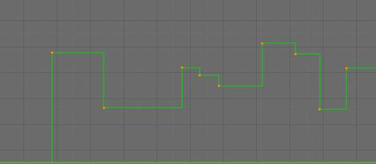
Constant.
Linear
This simple interpolation creates a straight segment between each neighbor keyframes, giving a broken line. It can be useful when using only two keyframes and the Extrapolation extend mode, to easily get an infinite straight line (i.e. a linear curve).
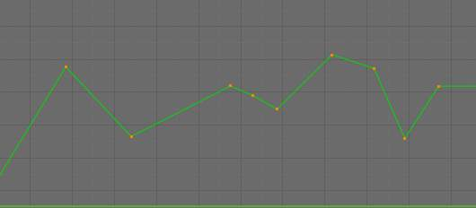
Linear.
Bezier
The more powerful and useful interpolation, and the default one. It gives nicely smoothed curves, i.e. smooth animations!
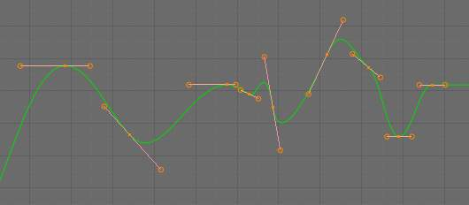
Bézier.
Remember that some FCurves can only take discrete values, in which case they are always shown as if constant interpolated, whatever option you chose.

Extrapolation
(Shift-E, or Channel ‣ Extrapolation Mode)
Extrapolation defines the behavior of a curve before the first and after the last keyframes.
There are two basic extrapolation modes:
Constant
The default one, curves before their first keyframe and after their last one have a constant value (the one of these first and last keyframes).
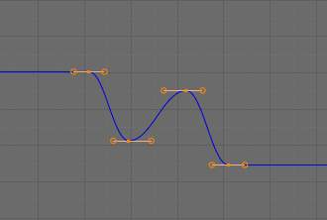
Constant extrapolation
Linear
Curves ends are straight lines (linear), as defined by their first two keyframes (respectively their last two keyframes).
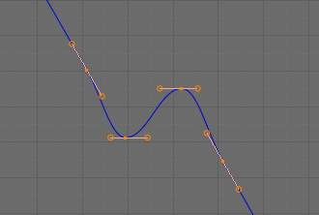
Linear extrapolation
Additional extrapolation tools (e.g. the “Cycles” F-Modifier) are located in the F-Curve Modifiers

Handle Types
There is another curve option quite useful for Bézier-interpolated curves. You can set the type of handle to use for the curve points V
Automatic
Keyframes are automatically interpolated
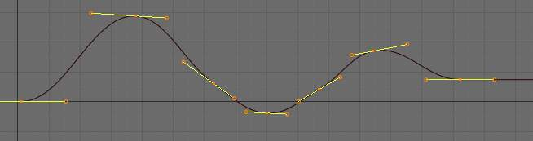
Auto handles
Vector
Creates linear interpolation between keyframes. The linear segments remain if keyframe centers are moved. If handles are moved, the handle becomes Free.
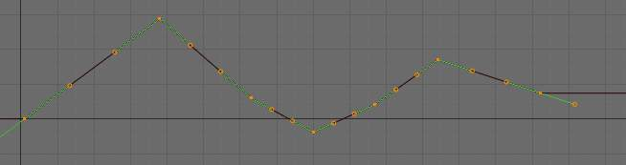
Vector handles
Aligned
Handle maintain rotation when moved, and curve tangent is maintained
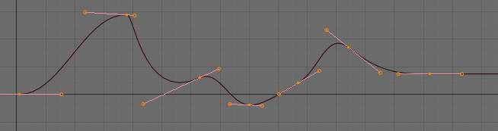
Aligned handles
Free
Breaks handles tangents
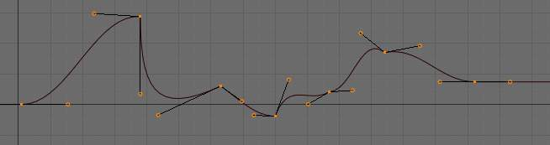
Free handles
Auto Clamped
Auto handles clamped to not overshoot
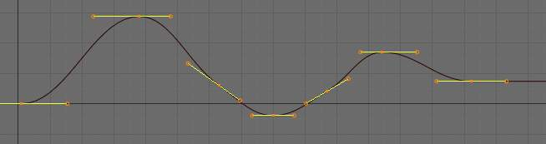
Auto clamped handles

Direction of time
Although F-curves are very similar to Bezier Curves, there are some important differences.
For obvious reasons, a property represented by a Curve cannot have more than one value at a given time, hence:
- when you move a control point ahead of a control point that was previously ahead of the point that you are moving, the two control points switch their order in the edited curve, to avoid that the curve goes back in time
- for the above reason, it’s impossible to have a closed Ipo curve

Two control points switching: the curve can’t go back in time!
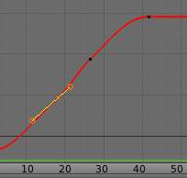  Before moving the second keyframe | 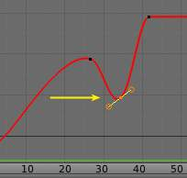  After moving the second keyframe

Editing Tools
By default, when new channels are added, the Graph Editor sets them to Edit Mode. Selected channels can be locked by pressing Tab.
Many of the hotkeys are the same as the viewport ones, for example Navigation hotkeys and select keys. Which one depends of the chosen keymap.
And of course you can lock the transformation along the X (time frame) or Y (value) axises by pressing X or Y during transformation.
For precise control of the keyframe position and value, you can set values in the Active Keyframe of the Properties Region.

Transform Snapping
When transforming keyframes with the navigation hotkeys the transformation can be snapped to increments.
Snap Transformation to 1.0 Ctrl
Divide Transformation by 10.0 Shift
Keyframes can be snapped to different properties by using the Snap Keys tool.
Snap Keys Shift-S
Current Frame
Snap the selected keyframes to the Time Cursor.
Cursor Value
Snap the selected keyframes to the Cursor.
Nearest Frame
Snap the selected keyframes to their nearest frame individually.
Nearest Second
Snap the selected keyframes to their nearest second individually, based on the FPS of the scene.
Nearest Marker
Snap the selected keyframes to their nearest marker individually.
Flatten Handles
Flatten the Bezier handles for the selected keyframes.

Flatten Handles snapping example.
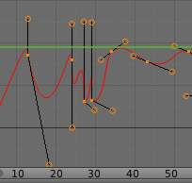  Before Flatten Handles. | 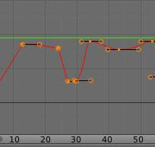  After Flatten Handles.

Mirror
Selected keyframes can be mirrored over different properties using the Mirror Keys tool.
Mirror Keys
By Times Over Current Frame
Mirror horizontally over the Time Cursor.
By Values over Cursor Value
Mirror vertically over the Cursor.
By Times over Time 0
Mirror horizontally over frame 0.
By Values over Value 0
Mirror vertically over value 0.
By Times over First Selected Marker
Mirror horizontally the over the first selected Marker.

Clean Keyframes
Clean Keyframes resets the keyframe tangents to their auto-clamped shape, if they have been modified. Clean Keyframes O
FCurve before cleaning | 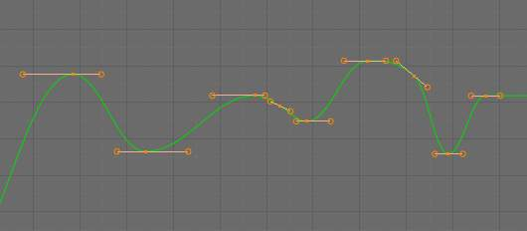  FCurve after cleaning

Smoothing
There is also an option to smooth the selected curves , but beware: its algorithm seems to be to divide by two the distance between each keyframe and the average linear value of the curve, without any setting, which gives quite a strong smoothing! Note that the first and last keys seem to be never modified by this tool.
FCurve before smoothing | 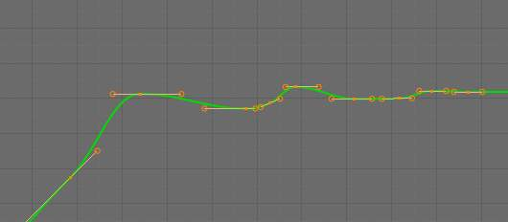  FCurve after smoothing

Sampling and Baking Keyframes
Sample Keyframes
Sampling a set a keyframes replaces interpolated values with a new keyframe for each frame.
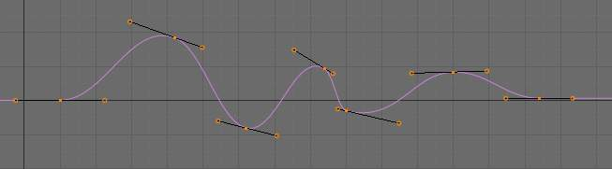  FCurve before sampling | 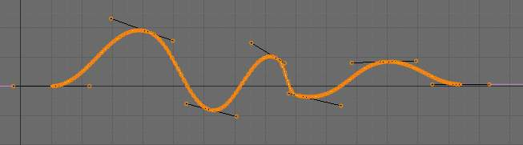  FCurve after sampling
Bake Curves
Baking a curve replaces it with a set of sampled points, and removes the ability to edit the curve.

F-Curve Modifiers

F-Curve modifiers are similar to object modifiers, in that they add non-destructive effects, that can be adjusted at any time, and layered to create more complex effects.

Adding a Modifier
The F-curve modifier panel is located in the Properties panel. Select a curve by selecting one of its curve points, or by selecting the channel list. Click on the Add Modifier button and select a modifier.
To add spin to an object or group, select the object/group and add a keyframe to the axis of rotation (x,y, or z)
Go to the Graph Editor.....make sure the f-curves properties panel is visible (View > Properties)
>Add Modifier > (e.g.) Generator

Types of Modifiers

Generator
Generator creates a Factorized or Expanded Polynomial function. These are basic mathematical formulas that represent lines, parabolas, and other more complex curves, depending on the values used.
Additive
This option causes the modifier to be added to the curve, instead of replacing it by default.
Poly Order
Specify the order of the polynomial, or the highest power of ‘x’ for this polynomial. (number of coefficients - 1).
Change the Coefficient values to change the shape of the curve.
See also
The Wikipedia Page for more information on polynomials.

Built-in Function
These are additional formulas, each with the same options to control their shape. Consult mathematics reference for more detailed information on each function.
- Sine
- Cosine
- Tangent
- Square Root
- Natural Logarithm
- Normalized Sine (sin(x)/x)
Amplitude
Adjusts the Y scaling
Phase Multiplier
Adjusts the X scaling
Phase Offset
Adjusts the X offset
Value Offset
Adjusts the Y offset

Envelope
Allows you to adjust the overall shape of a curve with control points.
Reference Value
Set the Y value the envelope is centered around.
Min
Lower distance from Reference Value for 1:1 default influence.
Max
Upper distance from Reference Value for 1:1 default influence.
Add Point
Add a set of control points. They will be created at the current frame.
Fra:
Set the frame number for the control point.
Min
Specifies the lower control point’s position.
Max
specifies the upper control point’s position.

Cycles
Cycles allows you add cyclic motion to a curve that has 2 or more control points. The options can be set for before and after the curve.
Cycle Mode
Repeat Motion
Repeats the curve data, while maintaining their values each cycle.
Repeat with Offset
Repeats the curve data, but offsets the value of the first point to the value of the last point each cycle.
Repeat Mirrored
Each cycle the curve data is flipped across the X-axis.
Before/After Cycles
Set the number of times to cycle the data. A value of 0 cycles the data infinitely.

Noise
Modifies the curve with a noise formula. This is useful for creating subtle or extreme randomness to animated movements, like camera shake.
Blend Type
Replace
Adds a -.5 to .5 range noise function to the curve.
Add
Adds a 0 to 1 range noise function to the curve.
Subtract
Subtracts a 0 to 1 range noise function to the curve.
Multiply
Multiplies a 0 to 1 range noise function to the curve.
Scale
Adjust the overall size of the noise. Values further from 0 give less frequent noise.
Strength
Adjusts the Y scaling of the noise function.
Phase
Adjusts the random seed of the noise.
Depth
Adjusts how detailed the noise function is.

Python

Limits
Limit curve values to specified X and Y ranges.
Minimum/Maximum X
Cuts a curve off at these frames ranges, and sets their minimum value at those points.
Minimum/Maximum Y
Truncates the curve values to a range.

Stepped
Gives the curve a stepped appearance by rounding values down within a certain range of frames.
Step Size
Specify the number of frames to hold each frame
Offset
Reference number of frames before frames get held. Use to get hold for ‘1-3’ vs ‘5-7’ holding patterns.
Use Start Frame
Restrict modifier to only act before its ‘end’ frame
Use End Frame
Restrict modifier to only act after its ‘start’ frame

Dope Sheet

- Action Editor
  - Action Data-Blocks
  - Channel Menu
- The Dopesheet
  - Dope Sheet Modes
  - Interface
- Shape Key

Action Editor

In Bforartists Actions are a generic containers for F-Curves. Actions can contain any number of F-Curves, and can be attached to any data block. As long as the RNA data paths stored in the Action’s F-Curves can be found on that data block, the animation will work. For example, an action modifying ‘X location’ and ‘Y location’ properties can be shared across multiple objects, since both objects have ‘X location’ and ‘Y location’ properties beneath them.
The Action Editor window enables you to see and edit the FCurve data-blocks you defined as actions in the FCurve Editor window. So it takes place somewhere in-between the low-level FCurves, and the high-level NLA editor. Hence, you do not have to use them for simple Ipo curves animations - and they have not much interest in themselves, so you will mostly use this window when you do NLA animation (they do have a few specific usages on their own, though, like e.g. with the Action constraint, or the pose libraries).
This is not a mandatory window, as you do can edit the actions used by the NLA directly in the FCurve Editor window (or even the NLA Editor one). However, it gives you a slightly simplified view of your FCurve data-blocks (somewhat similar to the “key” mode of the FCurve window, even though more powerful in some ways) - and, more interesting, it can show you all “action” FCurve data-blocks of a same object at once.
Additionally, it also allows you to affect timing of the different keys of the layers created with the grease pencil tool.
Each “action” FCurve data-block forms a top-level channel (see below). Note that an object can have several Constraint (one per animated constraint) and Pose (for armatures, one per animated bone) FCurve data-blocks, and hence an action can have several of these channels.

Action Data-Blocks
As everything else in Bforartists, actions are data-blocks. Unlike FCurve ones, there is only one type of action, which can regroup all FCurve of a given object. You’ll find its usual data-block controls in the Action Editor header.
However, there is one specificity with action data-blocks: they have by default a “fake user”, i.e. once created, they are always kept in Bforartists file, even if no object uses them. This is due to the fact that actions are designed to be used in the NLA, where you can affect several different actions to a same object! Yes, this is the only way to use different actions (and hence, different FCurve data-blocks of the same kind) to animate a same object. But as you have to assign an action to an object to be able to edit it (and an object can only have one action data-block at a time), to have “fake users” guaranties you that you won’t lost your precious previously-edited actions when you start working on a new one!
This window shows, by default, the action data-block linked to the current active object. However, as with FCurvs, you can pin an Action Editor to a given action with the small “pin” button to the left of the data-block controls, in the header. This will force the window to always display this data-block, whatever the current selected object is.

Channel Menu
Delete (X)
Deletes the whole channel from the current action (i.e. unlink the underlying FCurve data-block from this action data-block).
Warning
The X shortcut is area-dependent: if you use it in the left list part, it’ll delete the selected channels, whereas if you use it in the main area, it’ll delete the selected keyframes...

Settings ‣ Toogle/Enable/Disable a Setting
Enable/disable a channel’s setting (selected in the menu that pops-up) - currently, “lock” and/or “mute” only.
Toggle Channel Editability Tab
Locks or unlocks a channel for editing
Extrapolation Mode
Change the extrapolation between selected keyframes. More options are available in the Graph Editor.
Expand Channels, Collapse Channels
Expands or collapses selected channels.
Move...
This allows you to move top-level channels up/down , or directly to the top/bottom.
Revive Disabled F-Curves
Clears ‘disabled’ tag from all F-Curves to get broken F-Curves working again

The Dopesheet

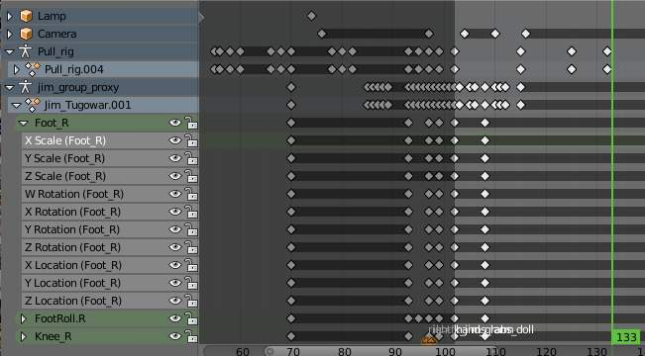
The DopeSheet
Classical hand-drawn animators often made a chart, showing exactly when each drawing, sound and camera move would occur, and for how long. They nicknamed this the ‘dopesheet’. While CG foundations dramatically differ from classical hand-drawn animation, Bforartists’s Dopesheet inherits a similar directive. It gives the animator a ‘birds-eye-view’ of every thing occurring within a scene.

Dope Sheet Modes
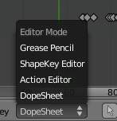
DopeSheet modes
There are four basic views for the Dopesheet.These all view different contexts of animation:
DopeSheet
The dopeSheet allow you to edit multiple actions at once.
Action Editor
Action Editor is the default, and most useful one. It’s here you can define and control your actions.
Shape Key Editor
ShapeKey Editor is dedicated to the Shape Ipo data-blocks. It uses/edits the same action data-block as the previous mode. It seems to be an old and useless thing, as the Action Editor mode handles Shape channels very well, and this mode adds nothing...
Grease Pencil
Grease Pencil is dedicated to the grease pencil tool’s keyframes - for each grease pencil layer, you have a strip along which you can grab its keys, and hence easily re-time your animated sketches. As it is just another way to see and edit the grease pencil data, this mode uses no data-block (and hence has nothing to do with actions...). Note that you’ll have as much top-level grease pencil channels as you have sketched windows (3D views, UV/Image Editor, etc.)

Interface
The Action Editor interface is somewhat similar to the FCurve Editor one, it is divided in three areas:
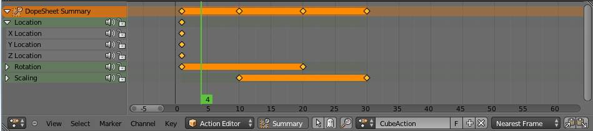
The Action Editor window, Action Editor mode, with an Object and Shape channels.
The header bar
Here you find the menus, a first block of controls related to the editor “mode”, a second one concerning the action data-blocks, and a few other tools (like the copy/paste buttons, and snapping type).
The main area
It contains the keyframes for all visible action channels. As with the other “time” windows, the X-axis materializes the time. The Y-axis has no mean in itself, unlike with the FCurve editor, it’s just a sort of “stack” of action channels - each one being shown as an horizontal colored strip (of a darker shade “during” the animated/keyed period). On these channel strips lay the keyframes, materialized as light-gray (unselected) or yellow (selected) diamonds. One of the key feature of this window is that it allow you to visualize immediately which channel (i.e. Ipo curve) is really affected. When the value of a given channel does not change at all between two neighboring keyframes, a gray (unselected) or yellow (selected) line is drawn between them.
The left “list-tree”
This part shows the action’s channel “headers” and their hierarchy. Basically, there are:
- “Top-level” channels, which represent whole FCurve data-blocks (so there’s one for Object one, one for Shape one, etc.). They gather all keyframes defined in their underlying FCurve data-block.
- “Mid-level” channels, which seem currently to have no use (there’s one per top-level channel, they are all named FCurves, and have no option at all...).
- “Low-level” channels, which represent individual FCurve , with their own keyframes (fortunately, only keyed Ipos are shown!).
Each level can be expended/collapsed by the small arrow to the left of its “parent” channel. To the right of the channel’s headers, there are some channel’s setting controls:
- Clicking on the small “eye” will allow you to mute that channel (and all its “children” channels, if any!).
- Clicking on the small “lock” will allow you to prevent this channel and its children to be edited (note that this is also working inside the NLA, but that it doesn’t prevent edition of the underlying FCurve ...).
A channel can be selected (text in white, strip in gray-blue color) or not (text in black, strip in pink-brown color.), use LMB clicks to toggle this state. You can access some channel’s properties by clicking Ctrl-LMB on its header. Finally, you can have another column with value-sliders, allowing you to change the value of current keyframes, or to add new ones. These are obviously only available for low-level channels (i.e. individual FCurve ). See View Menu below for how to show these sliders.

View Menu
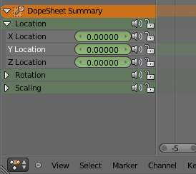
the action editor showing sliders
Realtime Updates
When transforming keyframes, changes to the animation data are flushed to other views
Show Frame Number Indicator
Show frame number beside the current frame indicator line
Show Sliders
A toggle option that shows the value sliders for the channels. See the The Action Editor window, Action Editor mode, with a group and sliders picture above).
Use Group Colors
Draw groups and channels with colors matching their corresponding groups.
AutoMerge Keyframes
Automatically merge nearby keyframes
Sync Markers
Sync Markers with keyframe edits
Show Seconds
Whether to show the time in the X-axis as frames or as seconds
Set Preview Range
Interactively define frame range used for playback. Allow you to define a temporary preview range to use for the Alt-A realtime playback (this is the same thing as the Playback Range option of the timeline window header).
Clear Preview Range
Clears the preview range
Auto-Set Preview Range
Automatically sets the preview range to playback the whole action.

Marker Menu
See the Markers page.

Shape Key
To do

Non-Linear Animation Editor

The NLA editor can manipulate and repurpose actions, without the tedium of keyframe handling. Its often used to make broad, significant changes to a scene’s animation, with relative ease. It can also repurpose, and ‘layer’ actions, which make it easier to organize, and version-control your animation.

Tracks
Tracks are the layering system of the NLA. At its most basic level, it can help organize strips. But it also layers motion much like an image editor layers pixels - the bottom layer first, to the top, last.
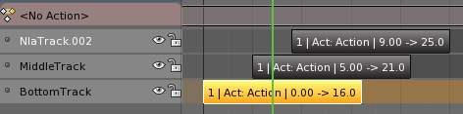

Strips
There’s three kinds of strips - Action, Transition, and Meta. Actions contain the actual keyframe data, Transitions will perform calculations between Actions, and Meta will group strips together as a whole.

Creating Action Strips
Any action used by the NLA first must be turned into an Action strip. This is done so by clicking the
next to the action listed in the NLA. Alternatively, you can go to
Reference
Menu: Add –> Action

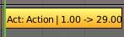
Action Strip.

Creating Transition Strips
Select two or more strips on the same track, and go to
Reference
Menu: Add –> Transition

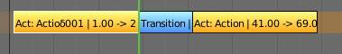
Transition Strip.

Grouping Strips into Meta Strips
If you find yourself moving a lot of strips together, you can group them into a Meta strip. A meta strip can be moved and duplicated like a normal strip.
Reference
Menu: Add –> Add Meta-Strips

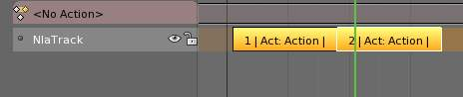  Shift-select two or more strips.. | 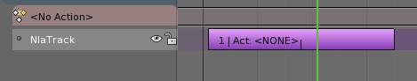  Combine them into a meta strip.
A meta strip still contains the underlying strips. You can ungroup a Meta strip.
Reference
Menu: Add –> Remove Meta-Strips

Editing Strips
The contents of Action strips can be edited, but you must be in ‘Tweak Mode’ to do so.
Reference
Menu: View –> Enter Tweak Mode

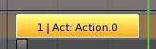  Strip in NLA mode.. | 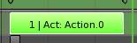  Strip in Tweak mode.
If you try moving the strip, while in edit mode, you’ll notice that the keys will go along with it. On occasion, you’ll prefer the keys to remain on their original frames, regardless of where the strip is. To do so, hit the ‘unpin’ icon, next to the strip.
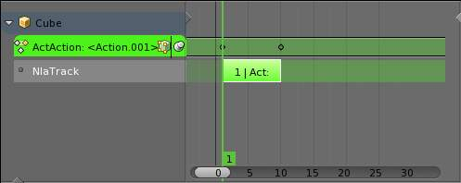
Nla strip with pinned keys.
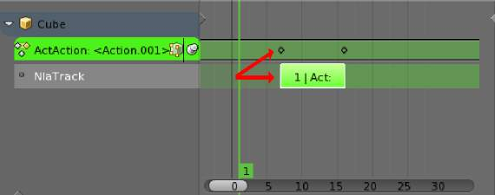
Strip moved, notice the keys move with it.
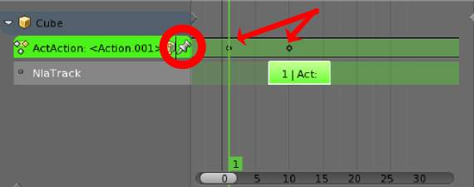
The unpinned keys return to their original frames.
When your finished editing the strip, simply go to View > Exit Tweak Mode. Note the default key for this is Tab.

Re-Instancing Strips
The contents’ of one Action strip can be instanced multiple times. To instance another strip, select a strip, go to

Reference
Menu: Edit–> Duplicate Strips

Now, when any strip is tweaked, the others will change too. If a strip other than the original is tweaked, the original will turn to red.
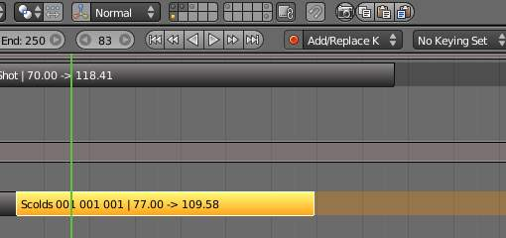  Original strip. | 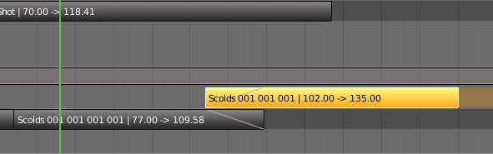  Duplicated strip. | 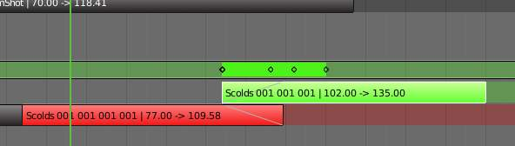  Duplicated strip being edited.

Strip Properties
Strip properties can be accessed via the NLA header.
Reference
Menu: View–> Properties

Renaming Strips
All strips can be renamed, in the “Active Track” section in the Strip Properties.
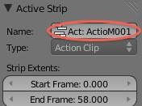

Active Track
This is which track the strip currently belongs to.
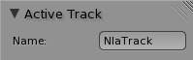

Active Strip
Elements of the strip itself. An Action Strip can be either an Action Clip, or a Transition Clip. Note that the ‘Strip Extents’ fields determine strictly the strip, and not the action. Also, the “Hold” value in the Extrapolation section means hold both beginning, and after. This can cause previous clips to not work, if checked.
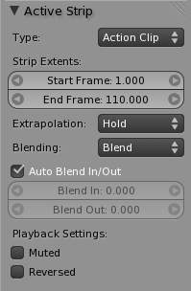

Active Action
This represents the ‘object data’ of the strip. Much like the transform values of an object.
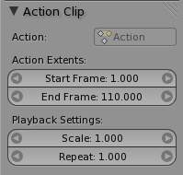

Evaluation
This determines the degree of influence the strip has, and over what time.
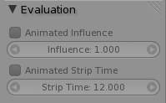
If influence isn’t animated, the strips will fade linearly, during the overlap.
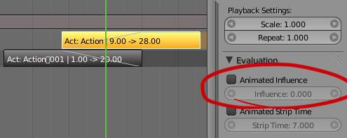

Strip Modifiers
Like its close cousins in mesh and graph editing, Modifiers can stack different combinations of effects for strips. Obviously there will be more to come on this.
